Aplicaciones de las TRIC para la enseñanza de ELE

Dra. Leyre Alejaldre Biel

Mahidol University International College

leire.ale@mahidol.edu

Materiales de la presentación: www.ELEdeLeyre.com/Chula

Edmodo
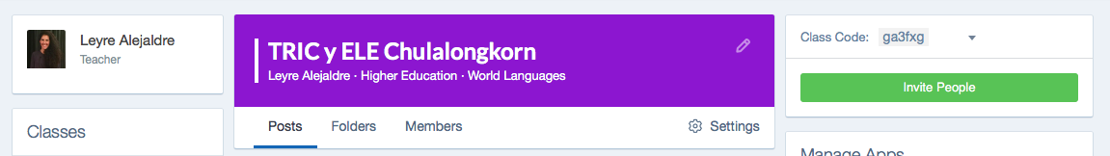

https://edmo.do/j/pdvwwb

Preguntas interactivas:
https://www.menti.com 86 76 11
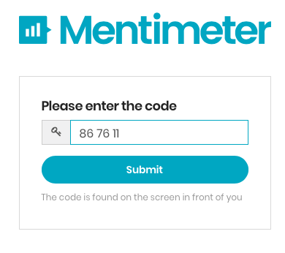
Actividad LinoIT

Actvidad Padlet

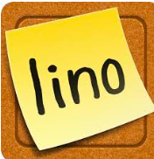

Actividad EdPuzzle Actividad Arcade
https://goo.gl/DEqfmx https://goo.gl/cxihP5

Herramientas TRIC
_____________________________________________________
_____________________________________________________
_____________________________________________________
_____________________________________________________
_____________________________________________________
_____________________________________________________

www.genial.ly | _____________________________________________________  _____________________________________________________  _____________________________________________________  _____________________________________________________  _____________________________________________________  _____________________________________________________
_____________________________________________________
_____________________________________________________
_____________________________________________________
_____________________________________________________
_____________________________________________________
_____________________________________________________

_____________________________________________________
_____________________________________________________
_____________________________________________________
_____________________________________________________
_____________________________________________________
_____________________________________________________

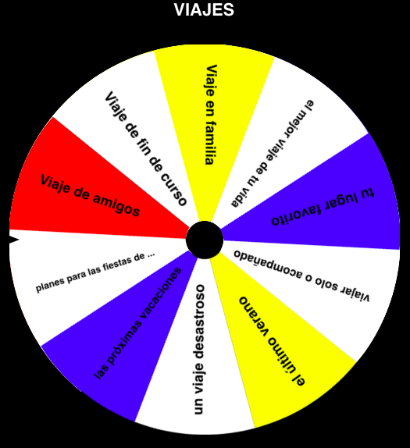 | _____________________________________________________  _____________________________________________________  _____________________________________________________  _____________________________________________________  _____________________________________________________  _____________________________________________________
_____________________________________________________
_____________________________________________________
_____________________________________________________
_____________________________________________________
_____________________________________________________
_____________________________________________________

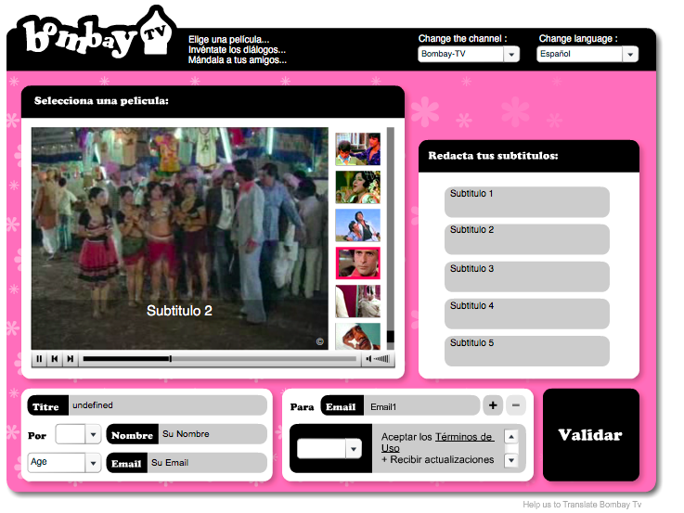 | _____________________________________________________  _____________________________________________________  _____________________________________________________  _____________________________________________________  _____________________________________________________  _____________________________________________________
_____________________________________________________
_____________________________________________________
_____________________________________________________
_____________________________________________________
_____________________________________________________
_____________________________________________________

_____________________________________________________
_____________________________________________________
_____________________________________________________
_____________________________________________________
_____________________________________________________
_____________________________________________________

_____________________________________________________
_____________________________________________________
_____________________________________________________
_____________________________________________________
_____________________________________________________
_____________________________________________________
_____________________________________________________
_____________________________________________________

_____________________________________________________
_____________________________________________________
_____________________________________________________
_____________________________________________________
_____________________________________________________
_____________________________________________________
_____________________________________________________

_____________________________________________________
_____________________________________________________
_____________________________________________________
_____________________________________________________
_____________________________________________________
_____________________________________________________
_____________________________________________________

Más recursos digitales

40 Herramientas TIC: | http://www.aulaplaneta.com/2015/05/12/recursos-tic/40-herramientas-para-aplicar-la-metodologia-flipped-classroom-en-el-aula-infografia/
Actividades gramaticales para la clase de ELE online | https://personal.colby.edu/~bknelson/SLC/
Actividades de audio, gramática y vocabulario | http://www.ver-taal.com
Recursos para los profes | https://www.profedeele.es
Gramáticas ELE con actividades | Nivel A1/2 https://marcoele.com/gramatica-a/  Nivel B1/2 https://marcoele.com/gramatica-b/
Presentación con TIC para explicar el Subjuntivo | https://marcoele.com/el-subjuntivo-es-logico/
Para explicar el estilo indirecto con TIC | https://terceragramatica.com/festival-de-clasicos-estilo-indirecto/
Indefinido/imperfecto | https://terceragramatica.com/lavatory-lovestory/

